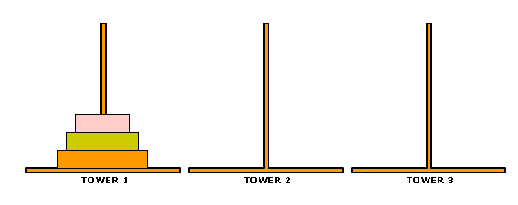**Tower of Hanoi**

|  |  |  |
| --- | --- | --- |
| **Actual Moves** | **Line of code that move takes place** | **Relevant function call** |
| Move ___ from Tower ___ to Tower ___ |  |  |
| Move ___ from Tower ___ to Tower ___ |  |  |
| Move ___ from Tower ___ to Tower ___ |  |  |
| Move ___ from Tower ___ to Tower ___ |  |  |
| Move ___ from Tower ___ to Tower ___ |  |  |
| Move ___ from Tower ___ to Tower ___ |  |  |
| Move ___ from Tower ___ to Tower ___ |  |  |